**201533661 이승수’s Mobile Programming Lab3**

**[HW2-1] Making an app for having context menu, which triggers to change text color.**

Create layout of button in MainActivity with activity_main layout and register colormenu ContextMenu to button. When button long-clicked, onCreateContextMenu() inflates ContextMenu. Color is selected, change button text color into selected RGB color.

**<MainActivity>**



ContextMenu registration to button_black

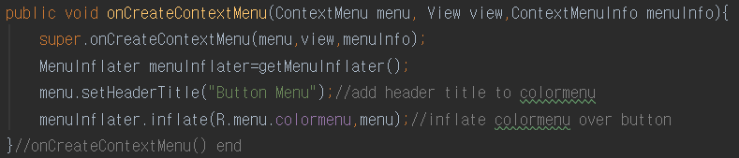

onCreateContextMenu() put header title and inflates colormenu RGB items to layout.

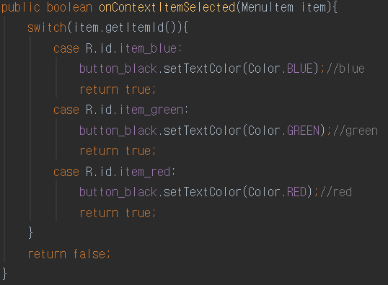

onContextItemSelected() change button text color into selected RGB color.

**[HW2-2] Making an app for “고객등록”, which include Edit Text, Radio Button & CheckBOXJ.**

When data inserted and button clicked, put each datas into myBundle and transport data from MainActivity to NewActivity with intent. appendIntentData() append data from bundle to each TextViews. When button clicked, move layout from NewActivity to MainActivity again.

**<MainActivity>**

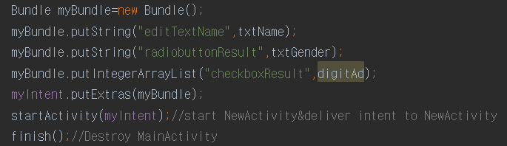

Put Views’ data into myBundle and transport it to NewActivity with intent. Finish() destroy MainActivity’s life cycle.

**<NewActivity>**

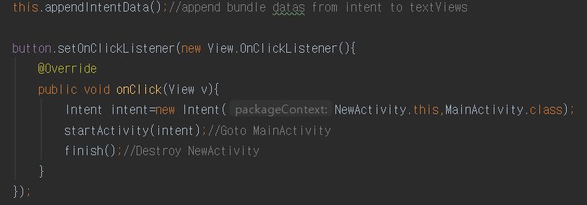

When button clicked, startActivity() moves layout to MainActivity again and finish() destroy layout.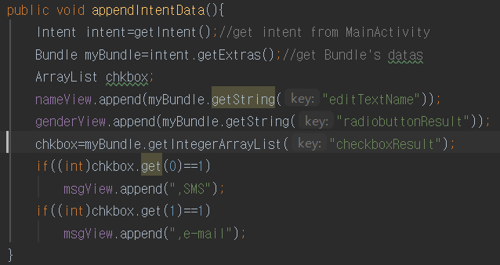

appendIntentData() append data from intent.myBundle into each TextViews. checkboxResult is Arraylist. It’s first index contains SMS information and second contains email information.